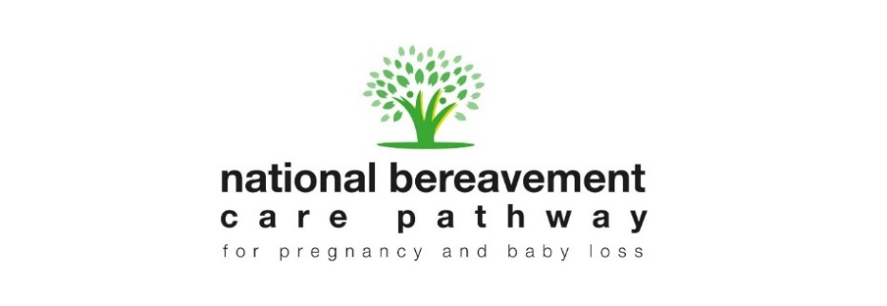National Bereavement Care Pathway:

Self-assessment tool

This self-assessment tool is an accompaniment to the National Bereavement Care Pathway (NBCP) pathway guidance documents available on [www.nbcpathway.org.uk](http://www.nbcpathway.org.uk). It is intended to enable Trusts to self-assess their current position against the [nine NBCP standards](https://nbcpathway.org.uk/sites/default/files/2019-05/Bereavement%20Care%20Standards.pdf) which underpin best practice in bereavement care, and develop an action plan to improve services to reach those standards accordingly.

This tool should also be completed in the context of the ‘10 tips for implementation’ as part of the welcome pack provided to each participating Trust; for example, on completing this self-assessment and action plan, we would ask all Trusts to make public their commitment to high standards of bereavement care, by publicising on their Trust website how they grade themselves in terms of the bereavement care standards: working towards compliance, compliant, championing standards (beyond the Trust).

The processes and resources referred to in this self-assessment tool are not exhaustive, and the tool should not be seen as a substitute or replacement for the pathway documents. Instead, this tool can be used prior to and following the introduction of the NBCP to look at existing bereavement care provision and consider what changes may be necessary to ensure that the NBCP standards are being implemented. By reflecting on how services are organised and delivered, and setting appropriate review dates, sites can develop a continually evolving plan to ensure they are providing the highest levels of care.

**Date assessment started:**

**Date assessment completed:**

**Lead person completing the assessment:**

**Next Assessment Date:**

**Additional notes:**

[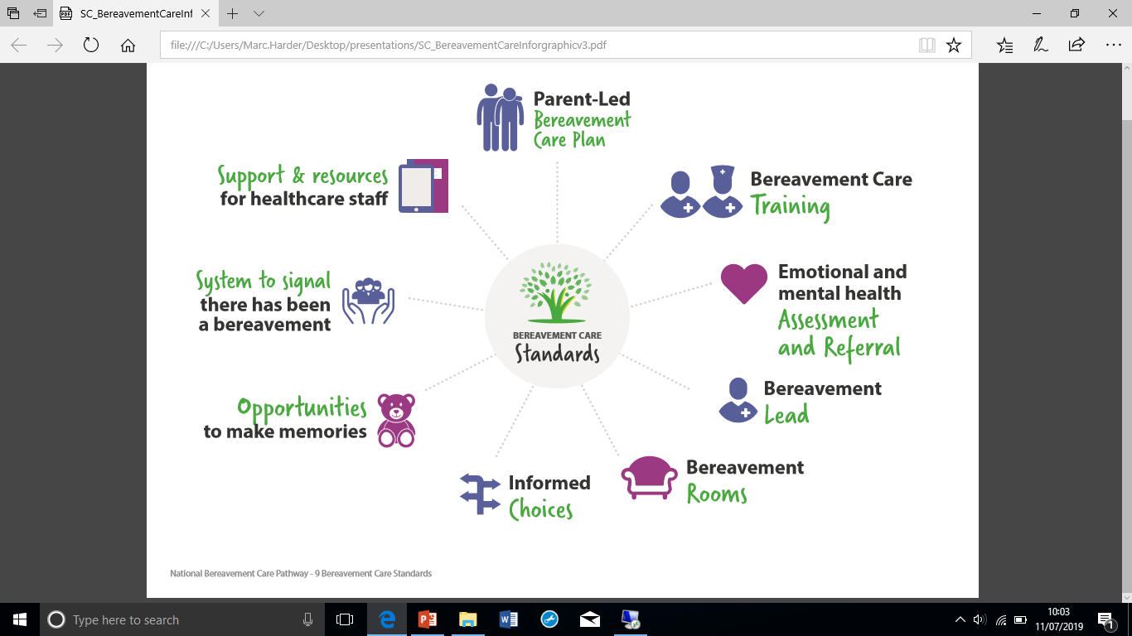](https://nbcpathway.org.uk/professionals/nbcp-pathways-material)**1. A parent-led bereavement care plan is in place for all families, providing continuity between settings and into any subsequent pregnancies**

*Bereaved parents have told us that sometimes services are not joined up and that care provision along the bereavement journey is inconsistent.*

An example of a good bereavement care plan is one that ensures that parents don’t have to keep on telling their story again and again to healthcare professionals who have not been informed of their loss. Parents are given appropriate and timely information to support their care pathway, have an input into this plan and it is centred around their needs. It is a plan which can be extended into subsequent pregnancies, providing additional support and continuity of care during an anxious time.

An example of poor bereavement care in this instance is one where the mother becomes ‘nobody’s patient’… she falls between services as no-one is ‘holding’ them. This can happen immediately after the death of a baby and/or during a subsequent pregnancy and can cause intense difficulty and distress.

Trusts should put in place a bereavement care plan that enables continuity between settings, and support during subsequent pregnancy. What evidence does your Trust have that it is reaching this standard and which pathways does this apply to?

|  |  |  |  |
| --- | --- | --- | --- |
| 1. ***The Bereavement care plan you have written ensures that:*** | ***Current Trust position & score*** *(working towards =1, compliant =2, championing =3)* | ***Evidence*** | ***Relevant pathways*** |
| Continuity of carer in hospital / unit is provided |  |  |  |
| Parental preferences are sought and noted in the plan |  |  |  |
| Parental preferences are enabled and respected |  |  |  |
| The plan is regularly revised as appropriate with verbal & written information regularly provided |  |  |  |
| Extra support and monitoring in each subsequent pregnancy are offered (appendix A9) |  |  |  |
| **Total** |  |  |  |



**2. Bereavement care training is provided to all staff who come into contact with bereaved parents, and staff are supported by their Trust to access this training.**

*Bereaved parents have told us that sometimes it is evident that staff are under-equipped to provide good bereavement care. Sands / Bliss audits in* [*2016*](https://www.sands.org.uk/professionals/professional-resources/audit-bereavement-care-provision-uk-maternity-units-2016) *and* [*2018*](https://www.sands.org.uk/audit-bereavement-care-provision-uk-neonatal-units-2018) *demonstrated that many Trusts do not provide sufficient mandatory training for staff.*

A Trust with an effective approach to bereavement care training is one which provides training specific to the death of a baby, helping healthcare professionals improve their skills and knowledge, increasing the confidence of staff to hold difficult conversations in a sensitive way. Bereavement care training will be available for all staff members on the unit who come into contact with bereaved parents. Effective Trusts demonstrate that staff are properly supported with dedicated time to access training, and keep up to date records of staff attendance.

Non-compliant services are those that do not provide access to bereavement care training for all staff working with bereaved families, or do not provide time or opportunities for all staff to access this training.

|  |  |  |  |
| --- | --- | --- | --- |
| 1. ***Bereavement care training*** | ***Current Trust position & score*** *(working towards =1, compliant =2, championing =3)* | ***Evidence*** | ***Relevant pathways*** |
| High quality bereavement care training is provided to all staff who come into contact with bereaved parents |  |  |  |
| Staff receive training that includes communication skills around supporting choice, making memories and delivering difficult news |  |  |  |
| All staff are supported by their Trust to access bereavement care training |  |  |  |
| Staff are provided with educational resources such as those on the NBCP website to support them in providing high-quality bereavement care |  |  |  |
| **Total** |  |  |  |

 **3. All bereaved parents are informed about and, if requested, referred for emotional support and for specialist mental health support when needed.**

*Bereaved parents need continuity of care within and beyond the walls of the hospital or unit where they are being cared for. Parents tell us that sometimes the care they receive in the hospital setting is not available on returning home because they don’t know / haven’t been told who to contact and/or they are not signposted to appropriate support providers.*

Parents should be informed about the support that is available to them when moving on from the hospital setting; healthcare professionals should be informed about the local and national options available to parents and take responsibility for referring onto these services as required. Healthcare professionals should know who they can contact within the hospital to carry out a specialist mental health assessment if required.

An example of effective bereavement care in this area is a hospital / unit that ensures that the needs of the bereaved mother and/or couple/family is/are considered and assessed prior to leaving the setting. They are given helpful, written information which enables them to access further support, and where appropriate the referral for this support is made.

An example of ineffective bereavement care in this area is one where the mother/family are left to their own devices, not provided with sufficient support and unable to access the care they need.

|  |  |  |  |
| --- | --- | --- | --- |
| 1. ***Referral for further support*** | ***Current Trust position & score*** *(working towards =1, compliant =2, championing =3)* | ***Evidence*** | ***Relevant pathways*** |
| There is a conversation with parents returning home and an assessment of their needs. |  |  |  |
| Staff are aware of local provision of services and how to make referrals. |  |  |  |
| Parents are given written / on-line details of national and local sources of support, with verbal explanation of their relevance. |  |  |  |
| **Total** |  |  |  |

**4. There is a bereavement lead in every healthcare setting where a pregnancy or baby loss may occur.**

*This specialist staff member should have an overview of all aspects of bereavement care. The bereavement lead role ensures high quality bereavement care is provided to all bereaved parents and their families whenever and wherever they need it. The role is strategic in its nature and will involve working across departments to ensure consistency.*

A compliant Trust is one with access to a Lead who ensures staff are upskilled, supported and resourced to confidently and effectively deliver parent-centred care. Their role may include organising training, ensuring best practice is implemented, enabling effective multi-disciplinary working across settings, ensuring staff receive appropriate support and supervision, and ensuring patient records relating to bereavement care are accurately completed.

A Trust with no bereavement care Lead, or one with an informal role which is not officially recognised by the hospital cannot be compliant. Ad-hoc roles or those with insufficient dedicated hours /resources will not cover the responsibilities required. If the majority of bereavement care is expected to be carried out by the Lead this cannot be considered an effective service as they are over-reliant on one individual.

|  |  |  |  |
| --- | --- | --- | --- |
| 1. ***Bereavement Lead*** | ***Current Trust position & score*** *(working towards =1, compliant =2, championing =3)* | ***Evidence*** | ***Relevant pathways*** |
| There is a designated lead responsible for coordinating care for bereaved parents. |  |  |  |
| A designated lead member of staff is responsible for ensuring systems, policies and protocols are embedded. |  |  |  |
| The lead has dedicated time in their work plan to be able to provide support for colleagues. |  |  |  |
| The lead has received bereavement care training specific to the death of a baby. |  |  |  |
| The lead ensures that systems are in place to upskill all staff, ensuring that they can provide sensitive and supportive bereavement care. |  |  |  |
| **Total** |  |  |  |

5. **Bereavement rooms are available and accessible in all hospitals.**

*Parents who have been able to use a bereavement rooms or a bereavement suite after pregnancy or baby loss tell us how much of a positive difference this can make to their bereavement journey. Sands / Bliss audits in* [*2016*](https://www.sands.org.uk/professionals/professional-resources/audit-bereavement-care-provision-uk-maternity-units-2016) *and* [*2018*](https://www.sands.org.uk/audit-bereavement-care-provision-uk-neonatal-units-2018) *demonstrate that many trusts do not have rooms or suites for parents to use, or if they do, they are on labour ward and/or next to rooms where healthy, newborn babies are crying and/or families are celebrating.*

An example of good care, whatever the nature of their loss, is one where parents have a private space. For example, an effective bereavement room is one which is located away from other new mothers, and/or is soundproofed, equipped with suitable facilities for the mother and family, including double bed, en-suite bathroom and small kitchen area where possible, comfortable and sensitively decorated. Typically they will have a cooling facility situated or be able to be placed in the bereavement room, so parents can spend time with their baby if they wish

Units without access to a dedicated bereavement room cannot ensure an adequate bereavement care environment. If a bereavement room is located where families can hear other babies and is not adequately soundproofed it can have a significantly negative impact upon bereaved families. Decorations that include pictures of mothers and live babies are not appropriate. Those not easily accommodating a cold cot for families to spend more time with their baby would not be considered adequate.

|  |  |  |  |
| --- | --- | --- | --- |
| 1. ***Bereavement room*** | ***Current Trust position & score*** *(working towards =1, compliant =2, championing =3)* | ***Evidence*** | ***Relevant pathways*** |
| There is a dedicated bereavement room/suite for parents where parents have privacy / time away from other families and babies, and where staff can have discussions with parents. |  |  |  |
| The bereavement room is soundproofed if located near where parents will be able to hear other babies and families. |  |  |  |
| The bereavement room/s are accessible to all bereaved families when they need them. |  |  |  |
| **Total** |  |  |  |

6. **The preferences of all bereaved families are sought and all bereaved parents are offered informed choices about decisions relating to their care and the care of their babies.**

*All care along the bereavement pathway should be parent-centred, enabling parents the opportunities to make choices which are enabled by well-informed staff, in a way which is relevant to the emotional, cultural and spiritual needs of the parents.*

An example of good bereavement care in this context is one where parents are given information regarding, for example, post mortem, which is timely, sensitive and appropriate to their needs. Parents are given time to make their decisions and guide professionals as to their wishes, rather than vice versa.

An example of ineffective bereavement care in this context is one where parents are given poor or insufficient information, and later on regret making a rushed or ill-informed decision relating to the care of their baby.

|  |  |  |  |
| --- | --- | --- | --- |
| 1. ***Parental preferences*** | ***Current Trust position & score*** *(working towards =1, compliant =2, championing =3)* | ***Evidence*** | ***Relevant pathways*** |
| Parent views are sought when offering appropriate post mortem arrangements. |  |  |  |
| Appropriate options for storing and transporting of the baby’s body are offered. |  |  |  |
| Appropriate funeral arrangements are offered by well-informed staff, with regular communication. |  |  |  |
| Appropriate support from chaplaincy is offered and provided as required / requested. |  |  |  |
| Appropriate systems gain feedback from families about care to inform improvement, e.g. MBEM and hospital reviews. |  |  |  |
| The views of all parents are sought, in particular with staff reaching out to parents from high-risk groups, minority cultures and faith groups. |  |  |  |
| **Total** |  |  |  |

7. **All bereaved parents are offered opportunities to make memories.**

*Many bereaved parents say that the opportunity to make memories helped them on their bereavement journey. Making memories is a ‘catch all’ phrase which includes the opportunity to hold and wash baby, options to see their baby or pregnancy remains, to create keepsakes, to have photos taken (often units have access to a remembrance photographer), write in a remembrance book, or take part in other commemorations. Time is also important for parents and can be as precious as a keepsake.*

An example of effective bereavement care in this context is enabling the parents to hold and/or see their baby and (for later losses) enabling parents to invite their family and/or friends into the bereavement suite to spend time with baby, offering them the opportunity to have specialist photographs taken and given opportunities to discuss appropriate next steps.

Ineffective care could be where the mother feels like a patient rather than a grieving mother and is rushed into next steps without these opportunities.

|  |  |  |  |
| --- | --- | --- | --- |
| 1. ***Making memories*** | ***Current Trust position & score*** *(working towards =1, compliant =2, championing =3)* | ***Evidence*** | ***Relevant pathways*** |
| As appropriate to the type of loss, parents are offered opportunities to see/hold/wash baby. |  |  |  |
| Parents are supported with memory making opportunities, e.g. taking hand and footprints and photos / other appropriate actions. |  |  |  |
| The unit offers parents the opportunity to create a lasting memorial, sign a book of remembrance or take other actions to commemorate. |  |  |  |
| Staff always offer parents the option of taking their baby’s body out of the unit (as appropriate to the relevant pathway- not SUDI), with parents given clear information about how to look after it and a form confirming their right to do so. |  |  |  |
| **Total** |  |  |  |

8. **A system is in place to clearly signal to all healthcare professionals and staff that a parent has experienced a bereavement to enable continuity of care.**   
*Parents often feedback that they have had to tell their story again and again because of poor communication between departments, teams and organisations, and that in doing so the pain of their grief journey is exacerbated. They may arrive at a unit which is not expecting them. They may receive ‘Bounty’ packs of mailshots which can be extremely upsetting.*

Good care looks like a bereaved mother receiving, instead of a post-natal appointment letter, a condolences letter from her GP offering support and access to services, because the GP has received immediate notification from the hospital that the baby has died.

Poor care looks like a Health Visitor knocking on the door asking to see the healthy newborn baby. [Both of these examples are as recent as 2018]

|  |  |  |  |
| --- | --- | --- | --- |
| 1. ***Systems in place*** | ***Current Trust position & score*** *(working towards =1, compliant =2, championing =3)* | ***Evidence*** | ***Relevant pathways*** |
| Paper and electronic systems ensure that all staff are aware when a woman is experiencing or has experienced a loss at the earliest opportunity. |  |  |  |
| All units/teams are informed of the baby’s death and systems ensure that parents referred to another unit are expected and received sensitively. |  |  |  |
| The system ensures that all professionals – in all departments – who see the mother are fully informed of the situation. |  |  |  |
| Antenatal clinic staff are always informed of the baby’s death and cancel remaining appointments |  |  |  |
| Designated staff ensure that mother’s GP and community midwife are informed of within one working day following a death (with consent). |  |  |  |
| All staff know, with consent, how to mark notes with Sands teardrop sticker or other marker. |  |  |  |
| **Total** |  |  |  |

**9. Healthcare staff are provided with, and can access, support and resources to deliver high-quality bereavement care.**

*Providing the right support and resources for staff is key to ensuring parents receive excellent care. Bereaved parents tell us that they recognise the emotional strain that the death of a baby can have on staff as well as parents themselves. Staff need to be given opportunities to work alongside experienced colleagues to provide opportunities to learn and practice new skills, and staff need support and mentoring in order to continue to provide high quality care.*

Good bereavement care in this context would include regular peer group support for staff as well as opportunities for reflective practice. All staff have the opportunity to talk about their experiences in caring for newly bereaved families, access to counselling, advice and time.

Ineffective bereavement care is where professionals have no support structures and are increasingly unable to cope with the stress and trauma that the death of a baby can bring, leading to poor care for the parents who need it most.

|  |  |  |  |
| --- | --- | --- | --- |
| 1. ***Staff support and resources*** | ***Current Trust position & score*** *(working towards =1, compliant =2, championing =3)* | ***Evidence*** | ***Relevant pathways*** |
| There is adequate and timely clinical and psychological support and mentoring for all staff who care for bereaved families. |  |  |  |
| Less experienced healthcare professionals are given opportunities to develop skills and confidence by providing care alongside experienced colleagues. |  |  |  |
| All staff are familiar with relevant best practice guidelines, such as how their role fits into the wider care experience for bereaved families. |  |  |  |
| Staff are familiar with and can access professional resources to assist sensitive and supportive care. |  |  |  |
| **Total** |  |  |  |
| **Grand total** |  | ***Below 60: working towards, 61-90: compliant, above 90 = championing*** | |

 **NBCP Action plan**

Now that you have completed the self-assessment, complete the action plan below, inserting new rows as required. Once complete, send the self-assessment and action plan to the NBCP team for info via [marc.harder@sands.org.uk](mailto:marc.harder@sands.org.uk) and add this to your website

|  |  |  |  |  |
| --- | --- | --- | --- | --- |
| ***Standard*** | ***Specific pathway area for improvement*** | ***Action(s) required*** | ***Responsible staff member*** | ***Deadline*** |
| 1. ***Bereavement Care plan*** |  |  |  |  |
| 1. ***Bereavement Care Training*** |  |  |  |  |
| 1. ***Referral process / assessment for further support*** |  |  |  |  |
| 1. ***Bereavement Lead*** |  |  |  |  |
| 1. ***Bereavement Rooms*** |  |  |  |  |
| 1. ***Parental preferences*** |  |  |  |  |
| 1. ***Making memories*** |  |  |  |  |
| 1. ***Systems to ensure continuity*** |  |  |  |  |
| 1. ***Staff support and resources*** |  |  |  |  |